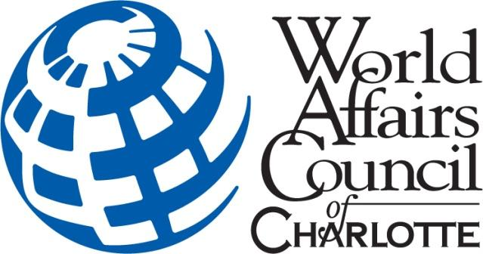

2022 WorldQuest / Academic WorldQuest
STUDY GUIDE

The WACC does not endorse any of the links or information provided on any of the websites recommended below. The study guide serves as “informational material” to help you begin your prep strategy. You are certainly not required to use any of the sources/links provided below in order to prepare to play.
Your WQ or AWQ team is encouraged to do additional research/studying/reading separate from this study guide.
2022 WorldQuest / Academic WorldQuest
STUDY GUIDE

The sources and sample questions provided are only meant to be a basic guide to help you begin preparing for WorldQuest or Academic WorldQuest.
PowerPoint slides for previous year’s WorldQuest/Academic WorldQuest are available online: http://www.slideshare.net/charlotteworld
Never played WorldQuest / Academic WorldQuest before? Check out highlights from past competitions:
- 2016 WQ & AWQ Video Highlights: https://vimeo.com/192010731
- 2016 WQ & AWQ Teaser: https://vimeo.com/170812894
- 2013 WQ and AWQ Video Highlights: https://vimeo.com/82294418
- 2011 WQ and AWQ Video Highlights: https://www.youtube.com/watch?v=ESvEiNLItzg
Who Can Play?
WorldQuest: Each team consists of UP TO 6 players.

Consisting of six (6) players, each team is is formed by businesses, government institutions, schools/colleges, non-profits or other self-determined groups. Individuals without a group will be assigned to a team by the Council.

Academic WorldQuest: Each high school in Mecklenburg, Iredell, Cabarrus, Gaston, Lincoln, and Union County can send two (2) teams of four (4) students each to represent their school in the Academic WorldQuest competition.

How are WorldQuest and Academic WorldQuest Played?

- Each category will have 10 questions. The majority of questions will be multiple choice.
- Each question is typically allotted 20-30 seconds though there will be at least 5-7 questions (total) requiring extra time (45 seconds to 2 minutes).
- Each team collaborates to answer each question before submitting their answer sheet at the end of each round.

What Do You Win?
- AWQ and WQ teams will be judged separately.
- Medals and trophies are awarded to 1st, 2nd and 3rd place winning teams for both WQ and AWQ.

How Should My Team Prepare?
The best way to prepare is to review international news coverage and our category descriptions on our website at www.worldaffairscharlotte.org

Academic WorldQuest 2022 Categories:

- World Flags
- Geography of Egypt
- World in Focus: Ukraine and Russia at War
- Global Economy: Inflation, Supply Chain, Energy, Digital Currency and More
- Combating Food Insecurity
- Current Events (2021-2022)
- Global Potpourri - Fun Facts about the World

CATEGORY 1: Flags of the World
Questions in this category will include identifying an image of a country’s flag or identifying a flag based on a description.
No multiple-choice options. Questions will be in fill-in-the-blank format.
Study Link
- Flags of the World – CIA Fact Book
- Flags of the World - Quiz

Sample Questions
- Identify this flag: __________________________ (write the answer on your answer sheet)

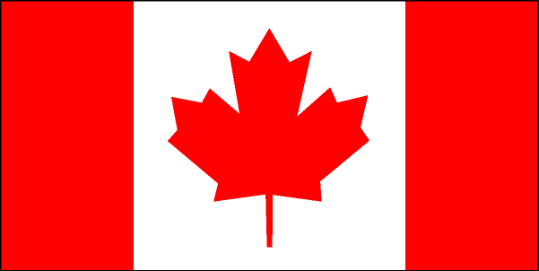

ANSWER: Canada

- This flag has two equal horizontal bands of azure (light blue) and golden yellow. These colors represent grain fields under a blue sky. Identify the country: __________________________ (write the answer on your answer sheet)

ANSWER: Ukraine

CATEGORY 2: Geography of Egypt

Geography of Egypt will cover a series of questions about maps, area topology, climate and atmosphere, ecology, mineral deposits and plant/animal distribution.
Most questions will be in multiple-choice format, but there could be a fill-in-the-blank and/or matching questions for variety.
Helpful Links
- Egypt and the Nile (Carnegie Museum of Natural History)
- Map of Egypt
- Egypt - Satellite Image
- Egypt Country Profile
- Trivia: Geography of Egypt
- Ancient Egypt: Geography of Egypt (Trivia)
- Egypt - Britannica
Sample Questions

- What is the capital city of Egypt?

A. Cairo
B. Alexandria
C. Giza
D. Luxe

2. The following countries border Egypt EXCEPT:

- Libya
- Iran
- Sudan
- Israel

CATEGORY 3: World in Focus: Ukraine and Russia at War
We will ask questions about the conflict between Ukraine and Russia focusing on impact, regional security in Europe, Russia’s role in the world, Ukraine’s war effort, and American foreign policy as it pertains to the ongoing conflict.
This topic covers a gamut of issues and remains an ongoing conversation all around the world. Your best method to keep up with what is going is to read the news from reputable media outlets and foreign policy think tanks (i.e. Brookings, CFR).
All questions will be in multiple choice. There will be 10 questions in this category.
Helpful Links:
- Russia’s War in Ukraine (CSIS)
- Russia’s War in Ukraine (RAND)Ukraine in maps: Tracking the war with Russia
- Russia-Ukraine war: List of key events, day 219
- Brookings - Ukraine
- Voice of America - Ukraine
- Why Is Russia Jeopardizing the Ukraine Grain Deal?
- Relations with Ukraine
- Radio Free Liberty Europe - Trivia

Sample Questions:
- On Sept. 30, Russian President Vladimir Putin announced Russian annexation of the following Ukrainian regions EXCEPT:

- Donetsk
- Luhansk
- Kherson
- Kyiv

- Before the start of Russia’s offensive, ___________ allowed the Russian Armed Forces to perform weeks-long military drills on its territory,
- Belarus
- China
- Kazakhstan
- Lithuania

CATEGORY 4: Global Economy: Inflation, Supply Chain, Energy, Digital Currency and More
We will cover general themes related to inflation, supply chain issues, trade, tariffs, energy prices, economic advantage, currency devaluation, and more as it relates to the global economy.
This topic covers a gamut of issues and remains an ongoing conversation all around the world. Your best method to keep up with what is going is to read the news from reputable media outlets and foreign policy think tanks (i.e. Brookings, CFR).
All questions will be multiple choice. There will be 10 questions in this category.

- What is inflation? (ECB)
- Causes and Impact: Inflation (McKinsey)
- Are economic headwinds blowing in the direction of a global recession? Chief economists answer
- How Do Economists Determine Whether the Economy Is in a Recession?
- Sweden and other central banks to test digital currency payments
- NPR - Global and Domestic Economy
- Strong Dollar is Good For the U.S, But Bad For the World
- Japan has the lowest inflation of all major economies but will continue feeling the pressure. Here's why
- War, Inflation Knock World Economy Off Balance
- Inflation could wreak vengeance on the world’s poor
- In the U.S. and around the world, inflation is high and getting higher
- Markets are reeling from higher rates. The world economy is next
- Europe’s Energy Crisis Is Destroying the Multipolar World
- Amid an energy crisis, Germany turns to the world's dirtiest fossil fuel
- China tests central bank digital currency use to settle trades via ‘bridge’ with partners including Hong Kong, Thailand and UAE
- Visualizing the Rise of Global Economic Uncertainty
- India’s central bank hikes interest rates to tame inflation

(THIS IS AN ONGOING TOPIC: This simply means you cannot rely completely on the links provided as it’s an ever-changing issue. Continue reading media coverage and think tank reports and/or blogs from Brookings, CSIS, Belfer Science and International Affairs, Council of Foreign Relations, Foreign Policy magazine and similar through mid-October 2022)
Sample Questions:
- ____________ from Russia, which is used to make Japan’s staple soba noodles, is another casualty of the Ukraine war, impacted by global supply chains uncertainty.

- Quinoa
- Buckwheat
- Millet
- Teff

2. This well-known sneaker said supply chains and too much inventory continue to hammer its latest
earnings results, with the company reporting inventories up 44% year-over-year and up 65% in North
America.

- Adidas
- Reebok
- Converse
- Nike

CATEGORY 5. Combating Food Insecurity

Teams are expected to understand the concepts around food insecurity including poverty and hunger, lack of (or unavailable) nutritious food in certain regions, impact of climate change on agriculture, and effect of war and conflict.
All questions will be multiple choice. There will be 10 questions in this category.

Helpful Links:
- World Bank - Food Insecurity
- World Food Program - Global Food Crisis
- Food Security - Peace Corps
- Global Food Security - McKinsey
- IMF Says Ukraine War Prompts Worst Global Food Crisis Since at Least 2008
- Global Hunger Index
- The world food crisis is about to get worse
- Sustainable Development Goals (Hunger)
- Food and Water Security (CFR)
- Food security and affordability (EU)

(THIS IS AN ONGOING TOPIC: This simply means you cannot rely completely on the links provided as it’s an ever-changing issue. Continue reading media coverage and think tank reports and/or blogs from Brookings, CSIS, Belfer Science and International Affairs, Council of Foreign Relations, Foreign Policy magazine and similar through mid-October 2022)
Sample Questions:
According to the Global Hunger Index 2021, which was adopted by the International Food Policy Research Institute, _________ was the most affected by hunger and malnutrition, with an index of 50.8. Yemen followed with an index of 45.1
- Sudan
- Somalia
- Haiti
- India
Hunger and all forms of malnutrition was expected to end by _____________ according to the mandate of the Sustainable Development Goals 2.
- 2030
- 2035
- 2040
- 2045
________________________________________________________________________________________
CATEGORY 6: Current Events
Think Big! This category generally covers major issues reported in the news from late 2021 through early October 2022. (i.e. world politics, elections, economic bailouts, natural disaster, major catastrophe, military engagement in Iraq and Afghanistan, national security etc.). The best way to keep up with current events is to review news reports from major news outlets.
All questions will be multiple choice. There will be 10 questions for this category.
Helpful Links
- Current Events – Wikipedia (*scroll down – events by month at the bottom)
- The Economist - The World This Week
- Current Events from InfoPlease
- New York Times - Quiz (Paywall)
- Foreign Policy Association - Quiz (Paywall)
- PEW Research - International Affairs Quiz
- BBC - *Quiz (*has weekly questions that include entertainment related topics which wouldn’t apply for this category of questions)
- CNN World
- Brookings Institute - International
- Tennessee WAC: What in the World? Weekly Quiz

1. According to legislation governing U.S. foreign assistance appropriations, the United States has withdrawn a $700 million aid package from __________ after General Abdel Fattah al-Burhan dissolved the government and declared a state of emergency in early November 2021, prompting protests in the country’s capital of Khartoum.
A. Egypt
B. Tunisia
C. Mali
D. Sudan

Answer: D. Sudan

2. On February 6, 2022 this year, Her Majesty Queen Elizabeth became the first British Monarch to celebrate a _______ Jubilee, marking 70 years of service to the people:
- diamond
- platinum
- golden
- sapphire

CATEGORY 7: Global Potpourri
Questions about fun/quirky/mainstream international popular culture (music, books, entertainment, festivals etc.), religion, food, ethnic groups, sports, and language are often part of this category.
Most questions will be in multiple-choice format, but there could be a couple fill-in-the-blank and/or matching questions for variety.

Helpful Links
- The Five Countries that Set World Culture
- 20 Holiday Traditions Around the World
- The Guardian - Quiz
- Global Business Etiquette
- Dances Around the World
- What are the 10 Most Spoken Languages in the World
- 21 Unusual English Expressions From Around the World
- National Flowers of the World - HGTV
There is no real way to “study” for this topic! It will be a “light-hearted” category with fun questions thrown in to close out the 8th round.
Sample Questions
- The meanings of colors play an important role in our world. They convey various emotions and hold different meanings to people of different cultures. What’s the most common significance of the color “red” in Chinese culture?

- Good luck and happiness
- Anger and masculinity
- Disturbance
- Sadness and mourning

- Which of the following is a polysynthetic language?

- English
- Greek
- Greenlandic
- Latin

